Alexander Baldree
08/11/26
Module 1.2 Assignment (GitHub)
CSD440

Github Link:
https://github.com/Panda-Alex21687/CSD440

Local Directory:
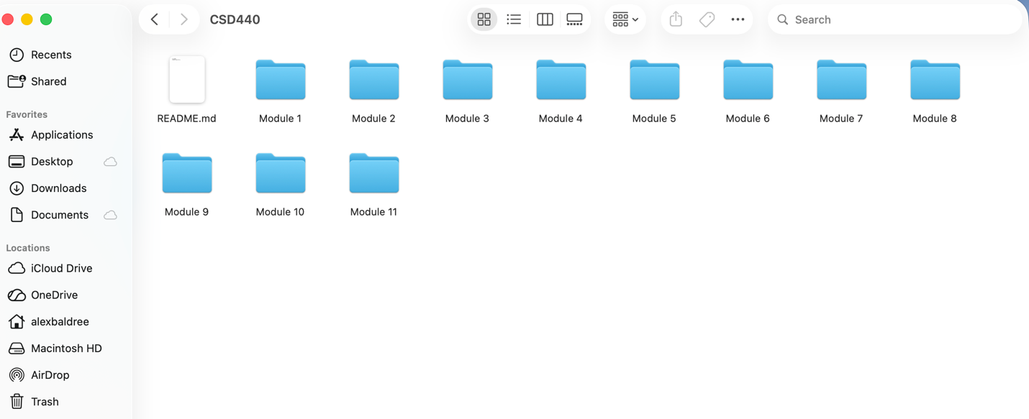

GitHub Repository:
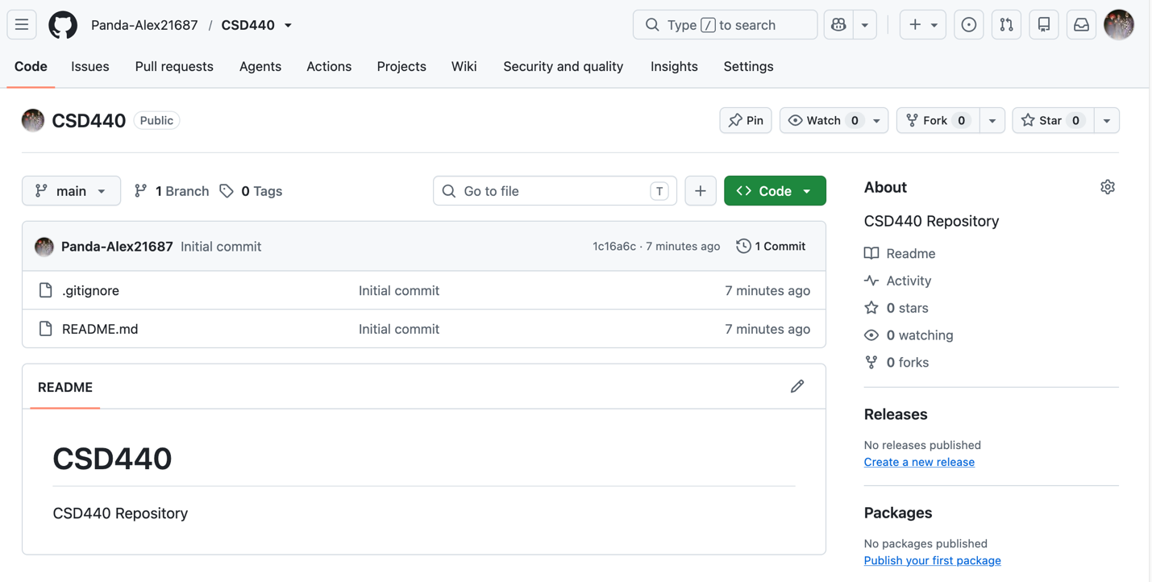

Terminal Directory:
